Day 01: Arrival Paro- drive to Thimpu

The flight into Bhutan takes you over the great Himalayas, offering the scintillating scenery of the world's highest glacial peaks.
As you enter Paro valley, you will see the silvery Pa Chu (Paro River) meandering down the valley, the Paro Dzong (fortress) and Ta Dzong (watch tower).

On arrival in Paro you will be received by our representative. Drive to Thimpu(55 Kms/ 01 Hr.). En route visit Simtokha Dzong, the oldest fortress of the Kingdom which now houses the School for religious and cultural studies.
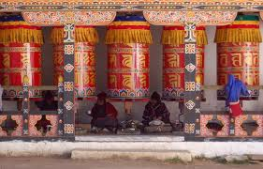
Evening visit National Memorial Chorten: The building of this landmark was envisaged by the third king, His Majesty Jigme Dorji Wangchuck, as a monument to world peace and prosperity. Completed in 1974 after his untimely death, it is both a memorial to the Late King (“the Father of modern Bhutan”) and a monument to world peace. The paintings and statues inside the monument provide a deep insight into Buddhist philosophy. Overnight at hotel

Day 02: Thimpu

There are a good many things to see in the capital which has a very relaxed, laid-back feel about it. Thimphu is relatively small having a population of approximately 90,000 people and the streets are wide and tree lined.
In the morning you will visit the Late King’s Memorial Chorten, the National Library, the indigenous hospital specializing in herbal medicine, handmade paper factory, and the nunnery at Zilukha.
In the afternoon, tour of the school of fine arts where young students learn the traditional arts and crafts (Zo Rig Chusum – the thirteen crafts); Zangtopelri Lhakhang, the Handicraft Emporium and the local handicraft centers to see the varieties of textiles, thangkha paintings, masks, jewellery etc. on display. Overnight at hotel
Day 03: THIMPU – Paro Departure

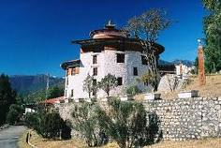
After breakfast drive to Paro(50 Kms./ 01 Hr.) Upon arrival check in at the Hotel and proceed to visit. Ta Dzong (Sun, Mon Govt holiday closed): once a watchtower, built to defend Rinpung Dzong during inter-valley wars of the 17th century, Ta Dzong was inaugurated as Bhutan's National Museum in 1968. It holds fascinating collection of art, relics, religious thangkha paintings and Bhutan's exquisite postage stamps. The museum circular shape augments its varied collection displayed over several floors.
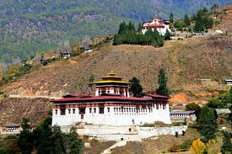
Afterwards, walk down a hillside trail to visit Rinpung Dzong, which has a long and fascinating history. Built in 1646 by Shabdrung Ngawang Namgyal, the first spiritual and temporal ruler of Bhutan, the Dzong houses the monastic body of Paro, the office of the Dzongda (district administrative head) and Thrimpon (judge) of Paro district. The approach to the Dzong is through a traditional covered bridge called Nemi Zam. A walk through the bridge, over a stone inlaid path, offers a good view of the architectural wonder of the Dzong as well as life around it. It is also the venue of Paro Tshechu, held once a year in the spring. Overnight at hotel

Day 04: Paro

Day excursion to Tiger's Nest
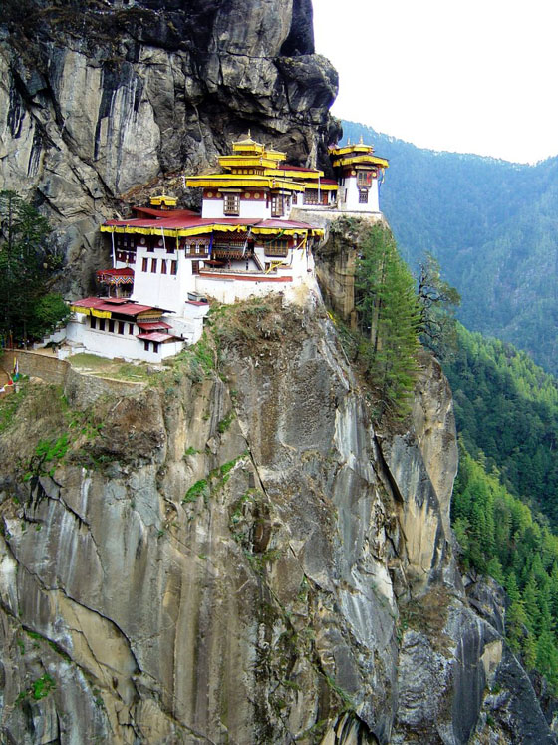
Taktshang or 'Tiger's Nest' as it is often referred to for Taktshang Pelphung monastery, is one of the most venerated and famous of Bhutan's monasteries. It is located on the face of a 900m sheer cliff. It is an impressive and unmissable site, but accessible only by walk or to ride mules/pony. From the trail head at Rumtokto (2600m), the walk till the Cafeteria is a steep one hour uphill (about 350m ascent). From the Cafeteria (2940m), one can get a good close-up view of Taktshang. Savor views of the monastery over a well deserved cup of tea and biscuits at the cafeteria and continue uphill for another 45 minutes to a high observation point (3140m) where there is a Chorten. From this vantage point, the lookout to the monastery is a very spectacular and seems almost close enough to touch. It is now on the other side of a deep chasm, only around 150m away as bird flies, but takes half hour or even more to reach. Continue down the flight of cliff-hanging steps on the narrow trail to a beautiful waterfall that plunges down the deep chasm and alongside is a retreat hermitage, jammed dramatically into a rock crevice. Then climb up the flight of steep steps to the monastery. At any point on this walk, you can always return if you find it too difficult. Once inside the monastery, there are several shrines or temples with few monks in residence. After visiting Taktshang monastery's many shrines, most tours schedule lunch at the Cafeteria upon return. After lunch, retrace back to the road-head where you started in the morning. The return from Cafeteria is all downhill and takes just over half hour. Further, if you have more time, energy and ready for more challenging day, you can start early and trek beyond Takstang to see several monasteries, temples, retreat houses in the surrounding area. The most notable among them are Zangdopelri and Ugyen Tsemo. Pony/horse can be hired for ride up till the Cafeteria. However you cannot ride beyond the cafeteria or come down hill on the horse. According to the legend, Guru Padmasambhava or Guru Rinpoche, who spread the Buddhism across the entire Himalayas is said to have flown here in the 8th century on the back of a Tigress, in order to subdue negative spiritual forces that were hostile to spread of Buddhism. In 853, one of his students, Pelgyi Senge mediated here in the main cave. The stupa inside one of the temples contains his mortal remains and therefore the cave is known as 'Pelphung or Pelgi's cave'. Subsequently many great spiritual masters such as Milarepa, Thangthong Gyalpo, Phajo Dugom Zhigpo, Shadrung and many others, passed periods here in profound meditation. In 1692, Tenzin Rabgye built a two storey temple around what little may have existed previously. This was expanded and refurbished many times over the period of time. Taktshang and several temples in the area were burnt down in 1951 by fire accident but much of them remained intact and most of the relics were saved. Soon after, the, Taktshang was rebuilt by population of Tsento village. Again in April of 1998, a major fire destroyed the main structure of the building and its contents (some believe it to be arson). Reconstruction began in 2000 and was completed and consecrated after extensive efforts and financial support of Governments as well as donors.

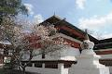
Kichu Lhakhang: Kyichu is one of the oldest temples in Bhutan built in the 7th century by Tibetan King Songtsen Gampo. The story goes that a giant demoness lay across Tibet and the Himalayas, which was preventing the spread of Buddhism. To overcome her, King Songtsen Gampo decided to build 108 temples in a single day to pin the ogress to the earth forever in 659AD. Of these 108 temples, 12 were built in accordance with precise plans at key points. The temple of Jokhang in Lhasa was built over the very heart of the demoness and Kichu is said to have been built on the left foot.

Day 05: Paro- Departure Flight

After breakfast in time transfer to Paro Airport to connect departure flight.

